**PROJECT MANAGEMENT SYSTEM**

**Team Member:**

* Jie Zhu
* Jing Wang

**Project Purpose and Content**

* **Purpose**

This project will deliver a UPS Express Management System, by which the ender users can track a package, estimate shipping cost and time, and create shipping requests.

* **Content**

The project will cover the following main aspects:

1. Package tracking, the system will list all shipment details and show the package movement route on the map. It will provide a alert service as well if the destination city’s weather is bad.
2. Shipping cost and time estimating, the system will list all shipping options. It will prompt the best price and the fastest option for the end users, users can choose one delivery option and create a shipping request.

**List of Technologies, Libraries, Components used**

* **Technologies**  
  C#.Net, Database(MySql)
* **Libraries**  
  Weather API, ShipEngine. ApiClient Libray
* **Components**Bing Maps WPF Control，Grid List View.

**Database Structure**

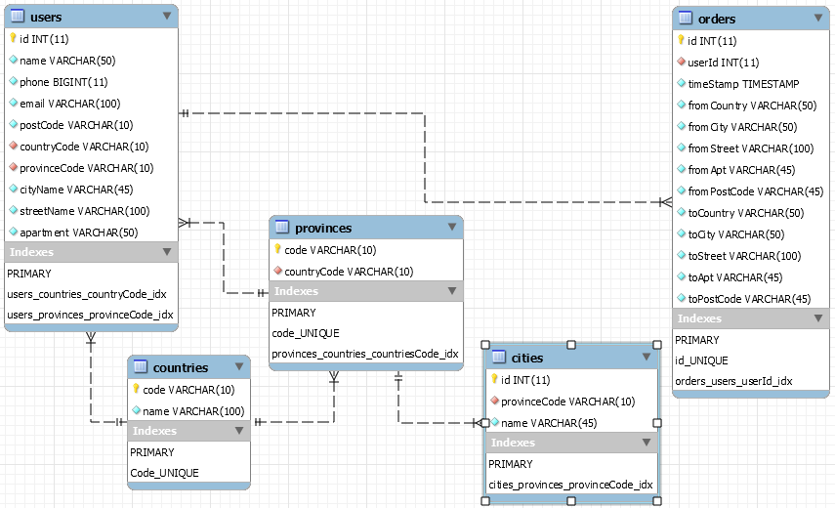

**Screenshots of Main Windows**

**Login**

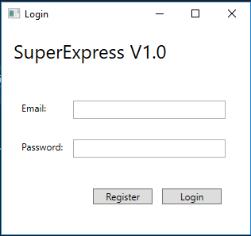

**Register**

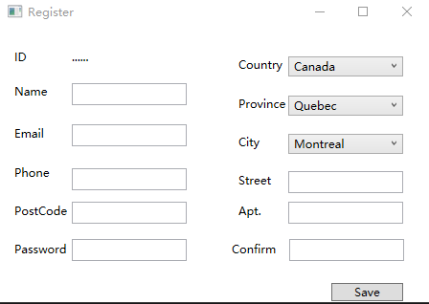

**Compare rate**